Report to NARI

REVIEWING EXTENSION MATERIAL
IN PNG AGRICULTURE

Dave Askin
Kilu Consulting

July 2018

Table of Contents
1 Introduction- and scope of this report 1
2 How do farmers learn and change? 1
3 NARI Toktoks – an overview 3
4 Evaluating current extension messages 4
4.1 Are NARI extension messages understood? 4
4.2 A broader context required? 4
4.3 Drawings or colour images? 6
4.4 Photos 7
4.5 Pictures or words? 8
4.6 Details matter! 8
4.7 Technical oversight 9
4.8 A role for videos? 9
4.9 For further information contact 11
5 Technologies chosen by communities in association with NARI teams 12
5.1 Introduction 12
5.2 Food storage and processing 12
5.3 Drought and disease tolerant lines of local starch and other crops 12
5.4 Fire 13
5.5 Post drought strategies to speed up food production? 13
5.6 Water supplies and irrigation strategies 13
5.7 Livestock? 14
5.8 Minor technologies that some villages will use- include 14
6 Revising NARI toktoks relevant to EU Climate Change Action 15
6.1 Introduction 15
6.2 Food storage and processing 15
7 Envisaged – an E-Platform 16
7.2 Technology – hardware 17
7.3 Moving forward? 18
8 Conclusions and Recommendations 19
9 References 20
10 People contacted- and comments 20
11 Acknowledgements 20
12 Appendices 21
12.1 Evaluating available NARI toktoks 21
12.2 Taking photos for farmer extension programs 26

Tables
Table 1 NARI Toktoks produced by station in each year from 2002 to 2017. 3
Table 2 General topics covered by 149 NARI Toktoks between 2002 and 2017. 3
Table 3 Extension publications (Toktoks) available in 2018, by station / program (Grain is a sub-set of Bubia). 21
Table 4 TokToks produced in Aiyura 2002-2017 21
Table 5 Toktoks produced in Bubia, excluding those specific to Grain – 2002-2017. 22
Table 6 Toktoks produced in Bubia, by the Grain program 2002-2017 22
Table 7 Toktoks produced in Bubia, by the Grain program 2002-2017 23
Table 8 Toktoks produced in Bubia, by the Grain program 2002-2017 23
Table 9 Toktoks produced in Bubia, by the Grain program 2002-2017 24
Table 10 Toktoks produced in Bubia, by the Grain program 2002-2017 24
Table 11 Toktoks produced in Laloki, Central Province and in Tambul, Enga Province 2002-2017. 25

Table of Images
Image 1 Everlasting beans – P. coccineus – messages of value for some of the gardeners in PNG- cooler areas. ii
Image 2 With (left) and without (right) rabbit manure. 4
Image 3 Line drawings by Takus David – UoGoroka, Mechanic –used with permission of CARE International. 6
Image 4 A with and without comparison is an important part of extension processes. Use text in images clarify. 7
Image 5 Reviewing photos and drawings - each image needs to tell the RIGHT story. 9
Image 6 Example of effective training video. 10
Image 7 Contact information details provided on NARI toktoks. 11
Image 8 Micro seed store – requiring very dry seed initially for long term, safe storage. 12

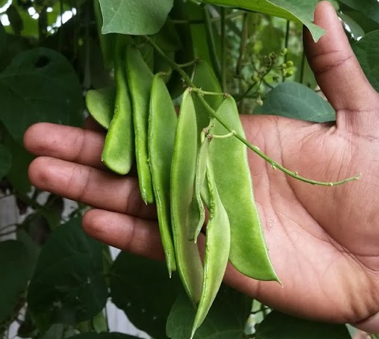
Image 1 Everlasting beans – P. coccineus – messages of value for some of the gardeners in PNG- cooler areas.

Introduction- and scope of this report
The EU Climate Change Action has provided an opportunity for NARI to seek an independent…
‘review on available learning materials produced by NARI and other agricultural and service providers in the sector.’
This review has been supported by -
- interviews with service providers, their lead personnel and those involved directly with farmer extension processes,
- discussions with key NARI staff,
- reading and evaluating NARI toktoks,
- and engaging with the 7,000 members ‘PNG didiman/meri’ on facebook
The review has been written with both the EU funded Climate Change Adaptations Action and NARI staff in mind – as those who will discuss and then implement as appropriate. There are times where it seemed appropriate to provide discussion starters on learning more generally - somewhat beyond the scope of ‘available learning materials’.
It would be easy in a review of this type to get bogged down in the details of almost 150 extension publications known as TokTok’s produced by NARI. That isn’t helpful. The review focuses on the key chosen strategies that are specifically important in climate change – focusing on the altitudinal zone of greatest concern in this action – lowlands.
The review starts by asking - How do farmers learn? What are the strategies that have worked best in PNG and elsewhere? That section starts below.
The report then provides a brief overview of the NARI toktoks and then proceeds to evaluate key aspects where improvements maybe made.
The community of researchers and extension officers broadly agree on key priority areas for communities facing drought and its associated fire and insect pest damage. The core focus has been developed as part of the initial community interactions in this EU funded Climate Change Action. Detailed results are stated elsewhere.
The core technologies are briefly discussed from page 12 and some specific toktoks are discussed in detail providing examples for how revision and improvement maybe made (refer page 15).
Videos have the potential to communicate stories that will capture the minds and heart of villagers and are technically possible with increased use of cell phones and solar panels for charging. That discussion – based in an approach known as an ‘E-platform’ is discussed starting on page 16.
Concluding statements and recommendations are provided on page 19.
Appendices cover background information on toktoks more generally and a ‘How to take great photos’ document starts on page 26.

How do farmers learn and change?
Is producing toktoks enough? We know the answer to that! It is a resounding NO, but given this is a review of ‘learning materials’ and the focus is more on learning and changes desired… – let’s consider models that have lead to successful change. People have tried many different methods
- Jesus used an apprenticeship model. History says that model worked incredibly well! Imagine if Jesus had run a brief weekend on ‘Life in the Kingdom’, handed out (toktok) notes in Latin – in case a Roman wanted to read and in Aramaic for his local readers with some Hebrew notes attached? End result? Not much… but this is sometimes what we hope for with villager training processes. Is there an important lesson to learn here? Repetition, demonstration, active men and women working together, with trainers… coupled with ongoing mentoring are keys to successful learning and change that builds resilient families and communities. These are the reasons NARI staff go to villagers and their learning materials need to support as many of these aspects of learning as possible.
Farmers may read the words – but fail to grasp the message!
- How might we test for comprehension that matters?
- What changes might we have to make in our delivery and interactions with village men and women – young and old?
- Does NARI test written material to ensure villagers – men and women, young and older -are ‘getting messages, clearly?
- NARI should test all written material before publication.
- Lutheran Development Service have for years placed trained, village motivators in villagers to live and demonstrate improved technologies. They have some reliance on printed materials, but their primary method relies on the dedication and skills of the local couple – attached to the yangpela didiman / didmeri program.
- Further afield, in Beirut, health workers rely on flip chart pictures to start the telling of a story, with trained motivators who add depth and knowledge. Illiteracy is no longer an issue.
- Where money is not a limiting factor, villagers may be brought to distant/central places to learn during a week or month or longer training program. Generally speaking we are much better to work with villagers in their own land, with their technologies to hand. Most successful are those technologies that do not rely on ongoing external inputs.
- Muntwiler and Askin’s 2004, ‘Training adults in PNG’ has useful insights for processes to consider as training modules are developed.
Into this context of working and demonstrating together, a well-produced toktok is an important provider of key messages that will help with successful sharing of ideas and technologies. The next section provides a very brief overview of NARI’s toktoks.

NARI Toktoks – an overview
The two tables below show a wide range of topics covered and a reduced publication rate of extension toktoks since 2008. There is a pressing need to evaluate, review and re-write some of the key toktoks. In this context, key toktoks will be those that integrate technologies into family and garden systems AND that speak directly to food resilience in the face of climate change.
For detailed information on the toktoks – please refer to Evaluating available NARI toktoks on page 21
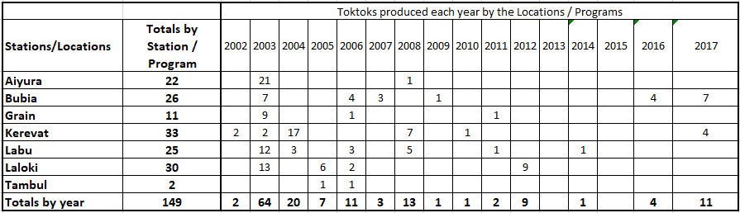
Table 1 NARI Toktoks produced by station in each year from 2002 to 2017.
Output by station and/or program is shown above and Table 2 below shows the core topics that have featured. In the recent past there have been a substantial number of rice and drought related toktoks. Well done to the Grain team in Bubia. Food preservation and the broad areas around spices and fruit and nuts has been well covered. The livestock team have also produced a substantial number of toktoks.
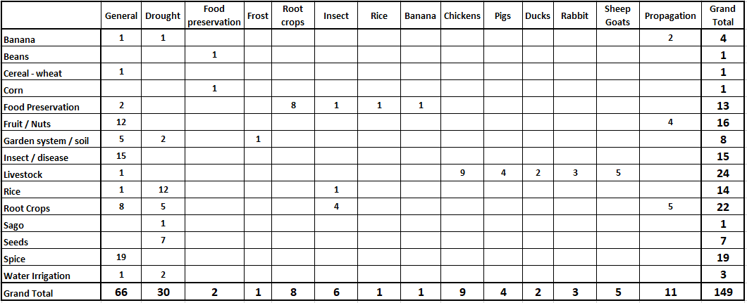
Table 2 General topics covered by 149 NARI Toktoks between 2002 and 2017.
Are there areas that need more focus? That is a matter for consideration making use of a broad range of input. The focus for extension development will be driven by two high level priorities –
- Villager choice/desires and
- Researchers’ experiences during droughts in the 1980’s, 1997 and more recently - 2015.
Neither aspect of priority setting should dominate. However, researchers bring experience of results that work, and that villagers may have never seen. Villagers know their unique situations and their own priorities must be heard and acted upon for their full engagement in the process of change.

The next section provides a range of suggestions intended to stimulate thought and lead to discussion around improving NARI extension messages.

Evaluating current extension messages
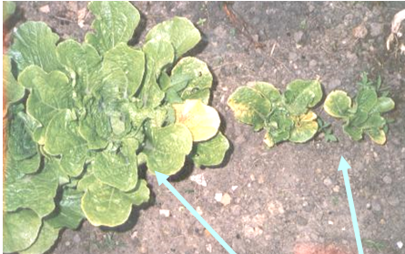
Image 2 With (left) and without (right) rabbit manure.
NARI has many messages of value for villagers facing climate change. This is clear.
The photo, from a Melanesian garden, highlights fertility challenges that can be at least partially overcome with some animal manure.

That is a simple message, worth sharing, worth incorporating into food resilience training.

How might NARI get their messages across more effectively?

This question is at the heart of each of the suggestions for discussion and action in this section.

Are NARI extension messages understood?
Several extension agents have indicated a fundamental concern. Farmers may read the words, but fail to grasp the message – the meaning.
How might NARI officers test for villager comprehension? A series of questions that are discussed?
Check with some local people – and ask questions after they have read the document. Don’t give them any help with the reading! They read, then you ask. That will guide you as to how useful your bulletin is as a stand-alone document. Make sure men and women are evaluated separately.
How often has NARI evaluated the ability of village men and women, both young and old to capture the key messages being shared in a toktok or other style of extension process?
Might a video be part of an approach that supports learning via written words? Might a demonstration out in the garden be even better – followed up by discussion at a next visit?
The answers are not simple and a variety of approaches will be needed.

A broader context required?
Papua New Guinea farmer gardeners have substantial – some would say massive challenges. Lutheran Development service put the challenges in three broad areas –
- Severity and
- frequency of climate related challenges,
- coupled with the squeeze on available land from ever increasing population pressure.
Their focus is primarily on the RFS – The Resident Farming system. They look to NARI and others to support their desire to take a holistic approach to the whole (traditional) system, seeking to see farmers as key components within the biological / spiritual system.
Do NARI toktoks take a ‘one technology by one technology’ approach, without looking enough at whole eco-systems, whole watersheds? Is there room to consider a broader approach with some new toktoks/videos telling stories that put the specific technology oriented toktoks into that broader context of watershed, village community and families?
The opportunity exists now for videos to tell some of that broader, integrated story of village life improving through the application of a range of new knowledge, attitudes and skills.
There are various ways villagers can engage effectively in learning new knowledge, attitudes and skills. Village maps can help encourage new ways of seeing – gaining insights into processes happening in a village that might otherwise go un-noticed..
Villagers might create three maps as an integral part of an extension process. Mapping can help them think together about their lives and where they are going … and where they want to go.
- The map created of the time when elders were young,
- today’s map of the village and water shed associated and
- what the villagers would like to see in a future, more food resilient future.
That is a powerful process setting the scene for a mindset towards positive and lasting change, into which individual, technology oriented toktoks find their rightful place.
The process itself of village mapping might form a toktok by way of explaining process. It might also be explained by a video that can be shared in ways that are relevant and possible across many locations in PNG.
Possibilities for videos to form an important part of the extension process are developed further in this review (page 9).
This report is focused on climate change and approaches that consider the whole farm system – people, soil, climate, water and water shed management, including erosion minimisation, livestock, markets – the whole rather than unique parts. The diagram in Figure 1 shows just one way of expressing the interdependence. With work, other layers may be included to add depth and interest and understanding of important features that are otherwise missed. For example, animals may benefit soil erosion by planting forages on contour lines. Presently, of course, free range pigs are significant contributors to both cultural pleasure and soil erosion.
Given the importance of top soil to water holding capacity in drought, systems to reduce soil loss must surely be high on the priority list for development?
An integrated approach might make use of a diagram like that shown below. What other approaches might get the same messages across? Are there approaches that really, truly fit a Melanesian context? Only insiders can truly answer this question. Here are some suggestions.
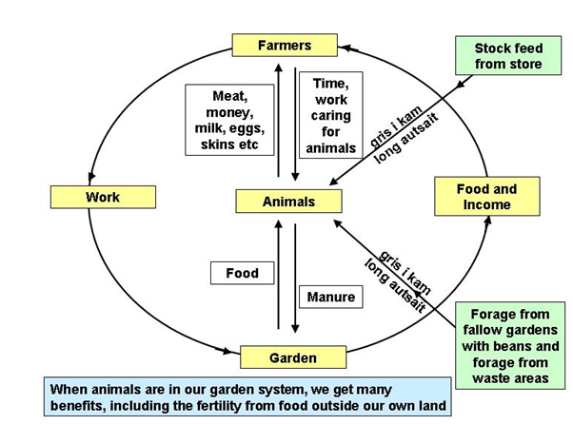
Figure 1 One method to show how livestock integrate with gardens
Would a story, told in a video, where the features in the diagram are discussed be more effective than the diagram alone in a toktok? Might it be more culturally appropriate and acceptable?
Now, take another look at the diagram. Does it seem flat and foreign, unlikely to speak to a Melanesian village setting? So … what do you think? Which is likely to be more effective?
- A video telling the story of a family who are living the intricacies described in Figure 1. –
OR
- The same figure, but this time, written about in a toktok and explained carefully by a well-trained village champion or extension officer?

Do extension officers suffer from a blind belief in the effectiveness of their extension processes, without ever really testing, looking to see what changes have occurred? Please take a moment to consider this question? This author believes changes occur slowly, incrementally and require considerable time and interaction with the real garden and real plants, people and animals to see lasting, positive change.
If this is true, then NARI extension processes need a multi-dimensioned approach.
If the story told by a family, in a video, is most effective – what stops NARI developing and testing some of those stories?
Maybe this communication challenge should not be either / or?

Maybe there is room for both approaches – each complementing the other?
Again, what do you think?

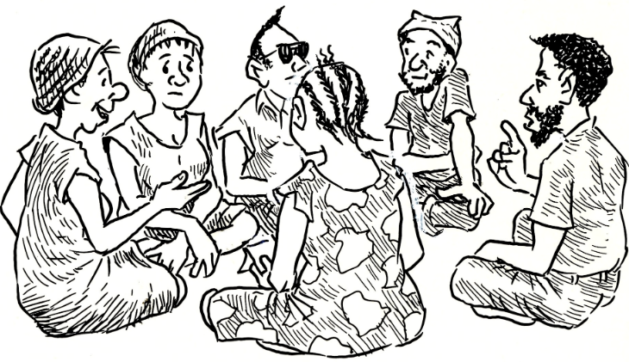
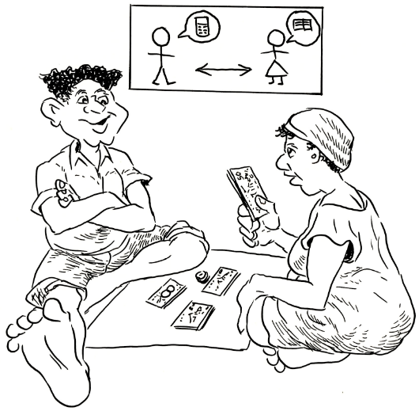
Image 3 Line drawings by Takus David – UoGoroka, Mechanic –used with permission of CARE International.
How might NARI officers determine how to be more effective when working with villagers? How might NARI develop a greater passion for excellence in all of these extension processes? Stop! That was a real question! It can’t be answered by yourself. It requires a cup or tea/coffee and discussion with colleagues…!

Here’s another question for discussion. Is NARI developing and testing complex garden systems described in Figure 1? NARI’s extension messages would carry a lot more weight, in this area were the livestock to be integrated with the garden AND the garden to have strong components of green manure for weed suppression, soil fertility improvement – and provision of forage for those same livestock.
Bundun Lutheran Centre on the Lae – Bulolo Road was perhaps a most effective model of the diagram referred to. It seems that Bundun’s integrated and site stable garden system has fallen into ‘disrepair’.
There is a need to see NARI and others working in gardens from the perspective of the villager. Not the researcher focused on just one aspect of crop, or soil or plant or animal. Integration will match and mirror the garden. Then NARI’s extension materials will also need to explore the intricacies, hopefully via stories of families who are successfully exploring integration.
Is this important? Yes indeed. Climate change requires answers that speak to a complex garden system.

Drawings or colour images?
It has become clear that an extension booklet, or a training manual, whether in Tok Pisin or in English will often be largely inaccessible to many village people. Some can read. Yes. But their reading does not lead to clarity around meaning.
Pictures and diagrams help. Keeping things simple seems the best way forward.
It would be great to develop and use local NARI staff with children or relatives who have excellent drawing skills to develop a series of pictures that speak directly to PNG situations.
While in Lae I bought various grades of pencil and handed paper and pencils to Kumaino in the Publications centre.
It would be reasonable – maybe sensible to see if there is local skill that can be developed for artwork in revised toktoks.

Photos
Only use photos where you must use a photo. Why? Photos are very hard to get really right. That shouldn’t deter us from photos. However, photocopy your beautiful colour version of the publication you are ready to distribute and look at the resulting black and white copy? Why ruin a great colour version with black and white photocopies? Because many will do this as a village based group don’t have the money to go and get extra copies made in colour. Please keep in mind a wider audience than just a funded project where colour is fine and accessible.
- Plan ahead – sometimes some months are required to create the right plant, livestock, watershed situation for an excellent photograph.
- Is colour needed or is black and white adequate?
- Does a photo really show what is needed? Might a line drawing be better and therefore reduce printing costs.
- Is the photo close up enough?
- Does the photo need a scale? A Match box, a biro, a pair of glasses, a car or door key – each is useful as a means to provide a sense of size. A cm rule is only used for formal publication purposes.
- Might a dark blue sheet act as a useful background, to help highlight the specific ‘something’ that the photo is trying to show?
- Do you need a photo in a photo – the plant with a closeup of flower or seed in a side box?
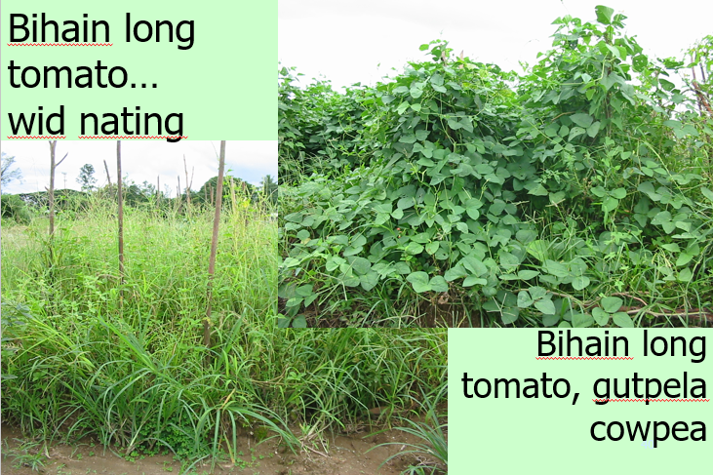
Image 4 A with and without comparison is an important part of extension processes. Use text in images clarify.
Once cowpea seed is provided and various means of using in green manures, with cooking methods explained, there is a good chance this technology will last.

Please refer to Page 26 regarding improving photos. Is this important? Yes! Many photos in NARI toktoks can be improved substantially.

Pictures or words?
The example below seeks to encourage careful use of insecticides -
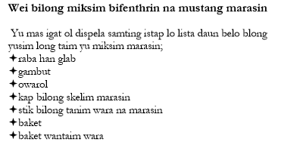 | What about a photo or possibly line drawing in place of the list of words that may not be in common use? (refer to list at left)  A picture is immediately clear and could have some balloons pointing to specifi items of importance for safety etc.  We might want to stress WHY we take precautions – safety – toxic chemicals.

The long list of words doesn’t quickly convey what is needed.

This kind of ‘mistake’ will occur while there is inadequate oversight and quality control over extension material production. What is needed is an eye looking less for technical correctness and more for how will the audience respond. That question needs to be answered by the farmers themselves – in testing of the materials provided.

Any videos NARI chooses to produce will likewise need careful oversight and planning and then final editing to ensure technical accuracy and clarity in communication.

Details matter!
Take the example overleaf. The girl on the left, in the drawing is going to be scratched by any normal village chicken.
The woman on the right is holding the chicken in a safe and calming manner that leaves one free hand – able to easily open and shut gates, cages etc.
The point of the two pictures below?
Each extension publication needs to be looked at in very careful ways and artists must be helped to understand details that are critical to success.
Once a person gets their eye in to this necessary evaluation/critiquing process, it is easy to look at pictures and see how the artist needed more careful guidance. Plants – eg maize – should look like maize – complete with tassles and cobs in the right place!
Authors must be thoroughly experienced in their field and able to look critically at each aspect of the extension publication.
- Seek advice.
- Seek second and third opinions.
- Then, remember to ask village people, both men and women to read and query comprehension or misunderstandings.
These are time consuming processes and demand a desire for excellence if our publications are going to be thoroughly effective – something to be proud of.
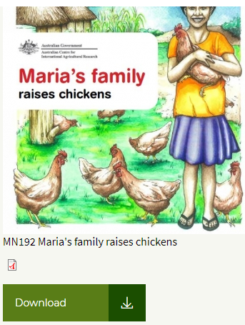 | 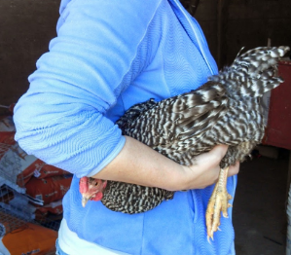
Image 5 Reviewing photos and drawings - each image needs to tell the RIGHT story.
https://www.aciar.gov.au/node/13081

Technical oversight
Various toktoks show a lack of technical oversight and checking.
Quality control is crucial. NARI must not publish toktoks without technical oversight from a group of experts in the field.

A role for videos?
A case has been made for some videos to share stories of successful incorporation of ideas into village life.
Videos are likely to be much more powerful in communicating a message – especially if a village family shares their story of making use of a new technology.
PNG has excellent communicators using videos to get messages across. People like stories and a story helps to create a sense of ‘if they can do it’, so can we…
Jennifer Waiko-Baing was visited near Umi bridge on the way to Goroka. She is a passionate gardener and skilled in video production.
If as envisaged in this report, videos become an important way of sharing information – there will need to be specific quality control.
- Use of tripods for example will need to be standard practice,
- Microphones will need to be protected from wind,
- Sound mixing, especially background music must not reduce clarity in spoken words,
- Effective editing to bring printed material into the video to enhance communication,
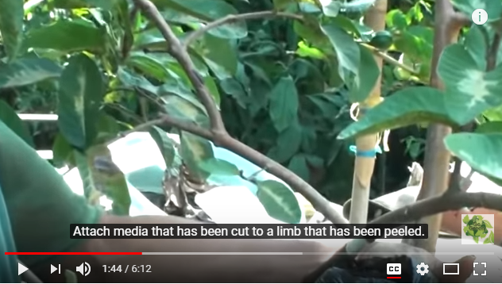
Image 6 Example of effective training video.
https://www.youtube.com/watch?v=TgKrIelx6WI i
- There’s much more to consider – expert advice will need to be sought,
- Testing with village men and women before ‘publication’ will be a must!
Here (on right) is an example of clarity with a technical task – aerial layering of fruit trees (Title – Air layering fruit trees – best method). The producers used clear short statements in simple English, along with clear white printed sentences on a black background that did not get in the way of the pictures.

The potential role for videos is discussed further in ‘Envisaged – an E-Platform’ on page 16.

Language- Care and standard use with Tok Pisin required
It is probably wise to keep Tok Pisin and simple English as the primary languages and determine whether end users need Motu?
Tok Pisin varies across PNG. A standard format and use of words should be applied to all Tok Pisin publications. Some words are worth being careful of.
A small i is common in Tok Pisin, and Microsoft Word will not allow this until an author has followed the steps below. FileOptions then follow steps below, by going into AutoCorrect Options.
Remove i becomes I.
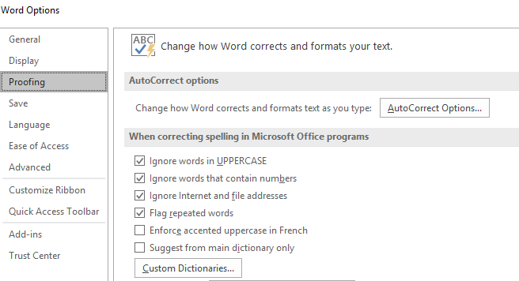
Ground can be giraun or graun. Prefer graun.
isave or should it be i save? Same with ino or i no? i gat or i gat? iken or i ken? NARI needs to make a choice with these options then be consistent.
Headings – perhaps one capital only, at start, then only capitals for the likes of Tapiok or Rice might be best?
Therefore Ol Sampela Gutpela Tapiok Bilong Nambis would change to Ol sampela gutpela Tapiok bilong nambis.

Does NARI need Buklet in the title of a publication? No! A standard naming process should be used across all toktoks. That means the title will not include a message stating this is a booklet. The whole series are booklets, so there seems no need to mention booklet in the title.
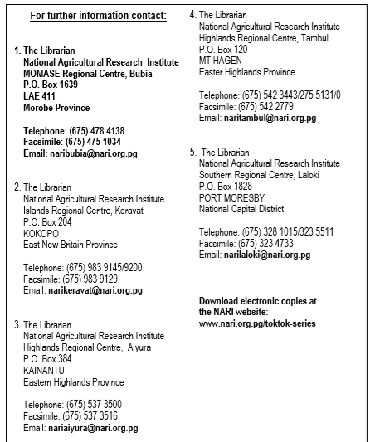
Image 7 Contact information details provided on NARI toktoks.

For further information contact
Is the level of detail provided in Image 7 really helpful or needed?
- Would people really post a letter when seeking information?
- Would they use a fax machine?
Much of the information overload on the screen here
…might be managed with just a few words giving an email and a few phone numbers?
Providing a way to download electronic copies is wonderful.
Does NARI need a dedicated person who answers farmer queries and sends the queries on to appropriate people? Yes indeed, and perhaps that might be best provided with a genuine commitment to engage via facebook?
That would require a very substantial and ongoing commitment.

Technologies chosen by communities in association with NARI teams

Introduction
This section provides some detail regarding scope of the EU Climate Change Action in terms of primary messages requiring a range of methods to ensure effective extension.
The technologies listed are the result of priorities being set during village survey processes and from experience of the research teams in NARI.
There is a need to address the extension ‘package’ for each of the chosen technologies. Toktok’s will need updating and in-line with this report, some videos telling a human story should be prepared.
Cost effective means of sharing materials with tablets have been discussed during the visit to NARI (June 2018) but detailed reporting and consideration of those matters is beyond the scope of this review. Suffice to say – there’s work to do with video production, and technology to support this.
Please refer to Envisaged – an E-Platform on page 16 for preliminary discussion.

Food storage and processing
During drought, starch becomes a critical limit to well-being among families. NARI researchers have developed techniques to both store and process a wide range of locally known starch crops.

Seed storage – micro and small scale- bottles/sealed bins
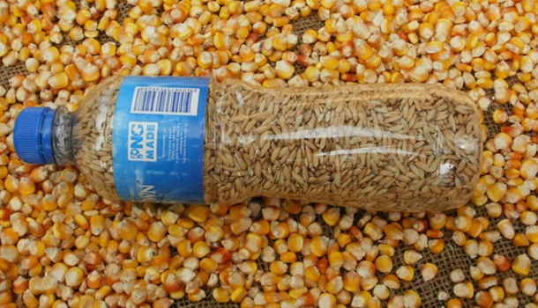
Image 8 Micro seed store – requiring very dry seed initially for long term, safe storage.
This includes maize/corn, rice, beans that can be stored by each family with training ensuring seeds are dry enough for prolonged storage. Refer toktok…
Rice, maize, beans (various)…

Cassava processing to chips and flour.

Drought and disease tolerant lines of local starch and other crops

Encouraging the planting and growing of traditional tree and vegetable crops known to support families during drought.
Families are encouraged to maintain and share information and planting material relating to traditional tree and vegetable crops. The President of Women in Agriculture – Maria Linibi is very keen to see these traditional crops promoted as part of drought and climate change resilience.

Encouraging the growing and harvest of mature corn for seed storage.
Africans and many South American cultures have for millenia relied on dry maize as staple starch crops. PNG villagers can learn from their experiences.

Encouraging the growing and harvest of rice for seed storage.
A considerable body of experience is available to draw on with rice. Processing rice is thoroughly energy intensive. Maize may be a more appropriate Melanesian answer to the need for long term starch storage. Both maize and rice will need insect and rat/mouse proof storage. Encouraging the storing of protein rich mung bean, cowpea, peanut and soybeans makes sense.

Drought tolerant, low cyanide lines of cassava produced and distributed by NARI
During drought cyanide levels rise in Cassava. Improved lines are an important component of resilience.

Early maturing sweet potato produced and distributed by NARI
Following drought, garden systems need to incorporate early maturing sweet potato and Corn to mop up excess nitrogen in soils that can hinder tuber development in sweet potato.

Yield increases through distribution of specific pathogen free sweet potato vines (virus and gall mite free vines)
NARI has some great research results. These need to be packaged in effective ways with videos helping people understand why fearing the outside lines of sweet potato is unwarranted.

Growing and storing African yam (includes minisets)
This crop introduced from Africa to PNG in the last twenty years or so has proven to be an excellent addition not only at low altitudes but is increasingly valued by highlanders also.
Yields per tuber are regularly exceeding 10 kg and providing a great deal of useful starch and satisfaction to the grower- in a root crop that stores well during drought.
This is a really winning technology that is sustainable in villages.

Drought tolerant lines of banana
During drought it is important farmers have access to top lines that can tolerate harsh conditions. Has NARI teams got the propagation areas planted to cope with increased demand?

Disease tolerant lines of Taro
NARI Bubia (June 2018) have a wonderful demonstration of taro lines. A simple video of each line showing health of leaves could be posted now along with some explanation of how some farmers are benefitting from wrapping taro in tobacco leaves at planting to reduce taro beetle damage.

Fire

Village wide agreements regarding fire risk and management
Fire is an extremely important issue when drought occurs – this was particularly evident in the 1997 drought and fires that destroyed many homes.

Post drought strategies to speed up food production?

Maintaining planting material for post drought recovery.

Taro minisets to maximise planting material

Water supplies and irrigation strategies

Water shed management – a whole of village approach
This is a large topic – that requires considerable discussion, but will include the role of trees, community agreements and irrigation technologies, village water supplies – siphons, ram pumps etc.
Trees are often banned by owners when dealing iwht long term tenants. Agreements around ownership and sharing are surely needed. Perhaps videos sharing stories of those who have allowed tree planting would be helpful.

Minimising erosion from steep gardens, maintaining soil fertility
Deep soils hold moisture and nutrients providing a resilient medium for growth during periods of stress. Soil loss needs to be minimised.
Ditches and intermound areas for sweet potato have trash placed to reduce soil loss.
Forage peanut and clovers in ditches to stop soil loss during heavy rain.
Green manuring enhances fertility, reduces weeds and reduces erosion. Green manure legumes carry fire much less than does a weed grass fallow.

Buckets, siphons, pumps and small scale garden irrigation.
Includes small gardens where root crops that are not propagated by seed, are maintained.

Livestock?

Minor technologies that some villages will use- include

Kaukau chips.

(For high altitude gardens NARI has a toktok specific to frost).

Revising NARI toktoks relevant to EU Climate Change Action

Introduction
Please forgive me if comments critique a toktok that you, the reader produced. The aim is to review some extension publications in detail to provide a sense of how a technical review (beyond the scope of this author and report) might work across each toktok that will be required to support the EU CC Action.

Food storage and processing

Seed storage – micro and small scale- bottles/sealed bins

BUB021, July 2016 (Eng) Making Cassava (Tapiok) flour.
These comments will not make sense without a copy of the toktok to hand.
I like the first picture – it shows a sealed bag – do we tell people how to seal the bags, where to get the blank roll of plastic from?
Are cellophane bags the same as plastic bags?
Plastic is increasingly viewed as a serious pollutant world-wide. Can we use the plastic bottles, with a paper funnel to fill bottles and use as re-useable storage? A photo would be needed.
On page 2 – processed into processed into – to correct.
The list of materials – photos ? That list isn’t actually complete!
Photos – try and think as a village person – that grinder – if needed – show an up close photo, perhaps opened up also? Where to buy? Likely cost?
The mortar and pestle are discussed – but no photo?
Materials list does not mention metal trays needed? What else would work if no metal trays or are they a critical item? Would ordinary plates be fine? If so, KISS (Keep it simple!).
Each and every photo – requires careful thinking – what is the most important item here? Are we showing that item clearly? What else might work if a villager can’t find ‘that’ item?
Photos could be larger to help make pictures clearer.
Wash the starch at the bottom of the pot – how? What does this actually mean?
Drying in the sun – assume drying on a rack of fly wire to allow air movement above AND below is preferred to drying on a plastic sheet?
Mill with hand grinder or wooden mortar and pestle – how to make, where to buy? Particular timber type required?
By the way – what test to know the product is thoroughly dry?
Finally – Two thoughts?
- Video may well be the best way to show what is required here!
- What are the ways a family might cook with this product?

BUB022 July 2016 (Eng) Making Cassava (Tapiok) crisps
This and the previous Toktok both suggest that the process happens during periods of climate stress. Perhaps there could also be a focus on preparation – PRIOR TO climate stress?
This needs some step by step working on, with someone who has never done this process. The materials list needs to be complete – everything needed and some sense of how much of each item if we want to make a particular weight or volume of crisps?
The primary photo of a plate of crisps is at odds with the message to grate – that photo shows grated strips?? BUT once again, photos are small relative to the particular item in the photo that needs attention. Be prepared to get close to the action!
It isn’t at all clear how these very light weight and bulky chips that are a wonderful snack (as indicated in text) BUT surely hard to store as a meaningful contribution to food security during drought?
Maybe this toktok needs to have removed the sense of being about food security in times of drought… or if that is the key idea – provide means to store?
I’d like to eat some of those – they look yummy!

Disease tolerant lines of Taro
Right now, at NARI Bubia a video story and photos are waiting and ready to be taken. NARI Taro lines are showing some great resistance to disease. One new line is not coping as well. That’s a great story to tell.

Minimising erosion from steep gardens, maintaining soil fertility
Deep soils hold moisture and nutrients providing a resilient medium for growth during periods of stress. Soil loss needs to be minimised.
Ditches and intermound areas for sweet potato have trash placed to reduce soil loss.
Forage peanut and clovers in ditches to stop soil loss during heavy rain.
Green manuring enhances fertility, reduces weeds and reduces erosion. Green manure legumes carry fire much less than does a weed grass fallow.

Buckets, siphons, pumps and small scale garden irrigation.
Includes small gardens where root crops that are not propagated by seed, are maintained.

Envisaged – an E-Platform
The Action intends to create an e-platform. Here is one vision, with two separate components for how this might develop.
It is an

E-platform to enhance extension processes
This section provides one view of how an e-platform might be developed to provide multiple values across the Action and beyond.
A key for long term success is to ensure the system is NOT based on proprietary software where data is accessible via monthly fee. Once the Action is completed – in that instance accesss to the information would be lost.
Rather, open source, LAMP architecture (Linux, Apache, My-SQL database and PHP), used already by NARI on its servers would be an appropriate and sustainable solution.
The goal is to provide direct benefit throughout the LLG’s in the Action and also allow others to access and benefit from the Action through the E-platform.
The E-platform would firstly allow access to
- Revised and newly created extension bulletins from within NARI,
- Training of training and training of community members in various forms,
- Other extension material gathered from various providers
- Videos that provide stories to discuss new ways of doing things and detailed training advice and
- Most Significant Change stories – presented as interviews on video, with visits to specific items of interest in the village garden, watershed, livestock, food processing/storage etc.
All of this would be pre-loaded on tablets provided to extension officers in the program, so there is no problem with inadequate and costly internet access.
The App developed under the E-platform budget would allow each tablet to download updated material to run off-line – whenever the tablet was connected to WIFI.
All of this public material would be available to those outside the Action – they would gain their access from a web-site which would link to an on-line library.
A preliminary example is viewable at http://gutpela-png-gaden.net/library/record/list
Those outside the action, might gain access to specific items via Bluetooth downloads and other free tools for file sharing that don’t require internet access – tablet to phone or tablet to tablet etc.
The E-platform would also allow access to
- Monitoring and Evaluation tool for agents in the field to capture particular specifics about training (Activity) and outputs (results – eg gardens planted, plant cuttings/seeds and animals provided / sold and outcomes – improved resilience measured in various ways (beyond scope of this report).
To achieve this, extension agents – RDO’s etc would need
- a tablet running an app that allows access to the two key tools above.
- a set of ‘backup kit’ as explained below in Technology – hardware on page 17.
The home screen on the tablet would run the specially designed EU CC app, and would show a number of high level options – click on one of those and drill down and down into more and more detail of resources informing the user – relating to farm systems (eg water shed management), soils, water, fire, plants, diseases, insects etc.
A side bar would allow filtering of the system – to show, for example just printed toktoks or just videos etc.
New videos or toktoks could be pushed into the tablet via the same app – but make use of various tablet to phone, tablet to computer technologies OR they would be downloaded directly off the EU CC website – e platform running live.
Users funded by our Action would also receive help to establish the system as a sustainable village level set of training tools that can be used informally and more formally.

Technology – hardware
The intent here is to have extension agents able to provide ongoing training.
Here’s a list of what could be provided
Item | Reason | Cost PNG Kina – very approximate
Tablet | Displays the videos, the documents etc. | 800
Charging for Tablet includes- |  | 0
12 V battery |  | 400
12 V solar panel, 2 x 85 W |  | 700
12 V / 30 Amp Solar Panel Controller with two usb ports to allow charging of phone and tablets and provide some lights to assist evening work. |  | 200
Lights, switches and cable in a package deal |  | 400
12 V LED micro projector – for some high performing extension officers. | An optional, but useful extra capability for those providing extension services to village farmers.  If officers were to travel to other villages a folding / roll up solar panel could be used to charge the projector with own battery.  This technology was being used by people DA met in PoM on way into PNG in MAPANG.  Pastor Dennis Carter  dencarter45@hotmail.com | 2000
Total per unit/per RDO | Approx. | 4500
Note a key cost is in the 12 V portable projector above. For many RDO’s and village champions the projector will not be a ‘must have’ item. The tablet itself will suffice for a small group to view and discuss.

Moving forward?
The same tablet could be used in the Action as part of Monitoring and Evaluation. The details of how that might work are developed in a separate scoping document being prepared by Alan Ferguson and Dave Askin, to allow PNG IT companies and others to quote from a level playing field.
Three key points were discussed during this input
The importance of
- Focus – a sharp arrow to deliver specific information at activity, output, outcome levels.
- KISS – keeping things as simple as possible and
- Remember to ask the So What? question – regularly and in many various places and times. We ran training, but so what? What were the outputs we can measure and what are likely, measurable outcomes?

Conclusions and Recommendations
Here are some thoughts for NARI staff and others to consider. The considering needs corn or peanuts and a cold drink. Or a hot coffee. Please discuss and add priority and your thoughts about how to improve extension messages and outcomes of extension processes.
- The initial phase of the EUCC Action has engaged effectively with village communities. Priorities are being set. Focus on those priority areas for initial improvements to extension materials.
- Extension is built on the excellence of research that underpins messages. Engage with all those who are learning and doing in agriculture. There are facebook groups, NGO’s, churches and government agencies to partner with.
- Extension is a process – that involves real people in real, complex gardens with dimensions that involve climate, erosion, plant, insect, disease, livestock AND people and complexity around land ownership and desires that don’t fit straight lines and simplicity. Extension needs to work within this complexity. To that end…
- Tell stories. Melanesians enjoy and relate to people’s stories. Tell stories around fires, tell stories with videos and tell stories with Toktoks. Even technically simple toktoks can still be told within the sense of story – a family as they learn and develop. Western education gets to the point in straight lines and blunt clarity. Can tok bokis – the story that is hidden in a box be used to improve the effectiveness of the extension processes?
- Population growth is a massive challenge in Papua New Guinea. How can NARI extension processes address this? Some would call this challenge the elephant in the room. In other words a massive challenge that is ignored as though it doesn’t exist.
- Much has been said of the need to tell stories – and one part of the answer has been argued here - use videos and tablets – based on the resources available for an E-platform.
- Engage in the complexity – starting with watersheds, involving trees and livestock and crops and food storage in complex whole systems where components benefit each other.
- Bring authors together in a series of workshops where the quality of each revised or new toktok can be improved. Have available technical people who can help with art work or video or language and style.
- NARI needs to ensure technical experts have critiqued each publication, each video before
- Test all written material before publication – responses from men and women should be sought in terms of their understanding of important messages.
- Photos must be high quality and care is needed – there are important features of photography that will lead to excellence in extension process.
- Line drawings can be very effective. Work with great artists. Find and grow great artists within NARI. Show examples to budding artists and see what they come up with.

References

ADRA – Disaster awareness training manual | Yet to be uploaded to library – below.
Markus Muntwiler, Dave Askin 2004. Training villagers in PNG – a manual for trainers. | http://gutpela-png-gaden.net/library/record/view/id/43
Maria’s family raises chickens. Retrieved 2018. https://www.aciar.gov.au/node/13081 | ACIAR have supported women in agri-business
Most significant change stories. | Eg http://evaluationtoolbox.net.au/index.php?option=com_content&view=article&id=61&Itemid=157 from google search – Most significant change stories.
Most significant change – training manual. This technique sits well with the approach being taken with this Action. | Google msc and Rick Davies Jess Dart to find url below  https://www.researchgate.net/publication/275409002_The_'Most_Significant_Change'_MSC_Technique_A_Guide_to_Its_Use

People contacted- and comments
Cathrine Boira Program Officer, Lutheran Development Service boiracathrine@gmail.com. 72420467
Leo Darius and Hosea Turbarat – not contacted – Integrated Agriculture Training Program – Vudal.
Debbie Kapal – FPDA and contract officer with CDWA – Community Development Workers Association. dbdkapal02@hotmail.com,
Bonnie Keoka, Program Manager Lutheran Development Service. bonniekeoka@gmail.com
Marlene Knijff – CARE Library – not contacted.
Maria Linibi – President, Women in Agriculture.
Andrew Puy –UniTech’s Appropriate Technology – LikLik Buk. Andrew.puy@gmail.com, 4734776; 76979090 73916352
Marek SoosADRA (WASH teams – Water and Sanitation and Hygiene). mareksoos@adra.org.pg. 73740695.
Dominic Wahiro M&E Officer. Lutheran Development Service. dwahiro1@gmail.com. 74847153
Jennifer Baing-Waiko – Video skills and passionate, skilled gardener – esp. around local garden plants and bio-diversity – in itself a strong part of food resilience in times of climate change. jbwaiko.savepng@gmail.com 75734834
Johnny Wemin, Director Extension Services, FPDA. jwemin1970@gmail.com

Acknowledgements
Thanks especially to Michael Dom, Action Co-ordinator for the EU Climate Change Action.
Thanks to the team of James Laraki, Jeffrey Waki, Aaron Inamara and others who have supported my input.
Best wishes to each of you.
Any errors and omissions are my fault.

Appendices

Evaluating available NARI toktoks
Aiyura | 22
Bubia | 26
Grain | 11
Kerevat | 33
Labu | 25
Laloki | 30
Tambul | 2
Grand Total | 149

Table 3 Extension publications (Toktoks) available in 2018, by station / program (Grain is a sub-set of Bubia).

This detailed listing of available toktoks was provided on a memory stick are presented in date order. This highlights those most likely to need revision.
The summary of Toktoks by station/location is provided below.

For one thing, many of the ‘How to contact us for further information’ statements provide email addresses that no longer work.
It also allows clarity around particular programs who have been active in supporting extension messages across NARI over the last few years.
This list represents many hours of research followed up by time spent presenting in a farmer ready format.
Farmers would want to say a big thankyou.
Let us continue to find ways of making these available to our farmers in various ways.

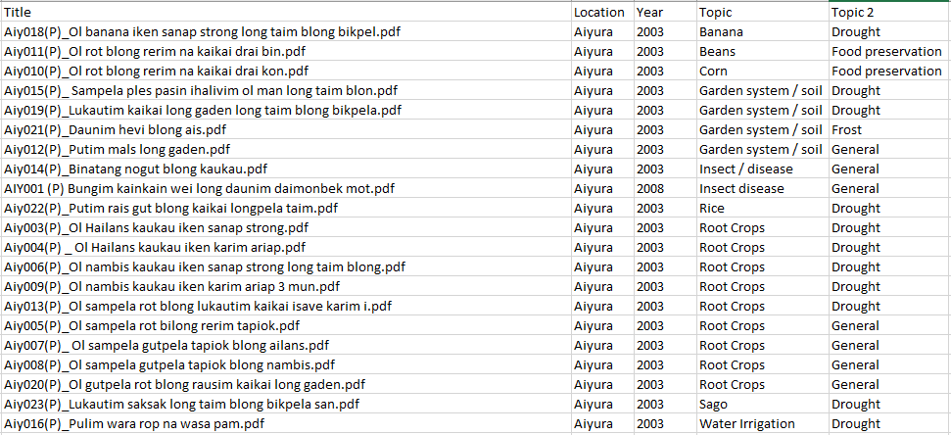
Table 4 TokToks produced in Aiyura 2002-2017

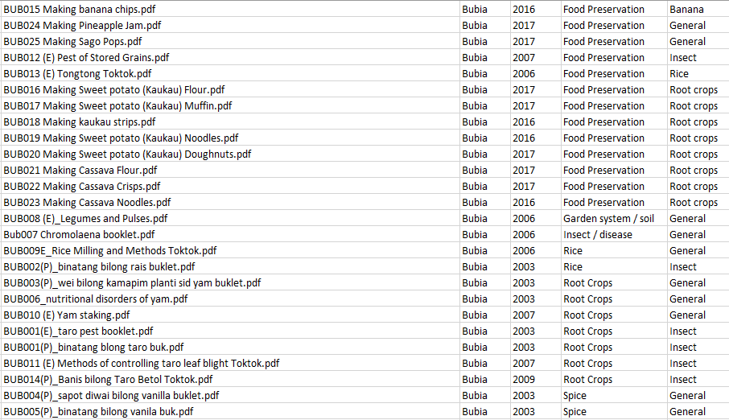
Table 5 Toktoks produced in Bubia, excluding those specific to Grain – 2002-2017.

Table 6 Toktoks produced in Bubia, by the Grain program 2002-2017

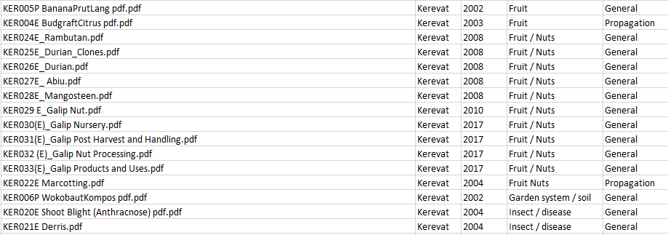
Table 7 Toktoks produced in Bubia, by the Grain program 2002-2017

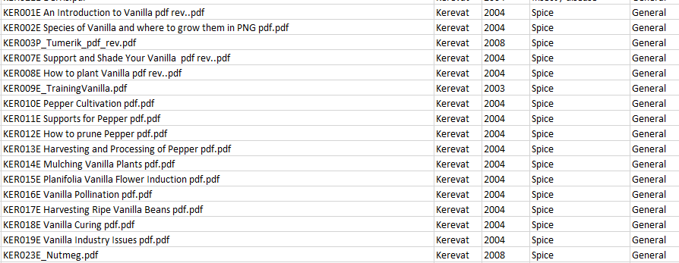
Table 8 Toktoks produced in Bubia, by the Grain program 2002-2017

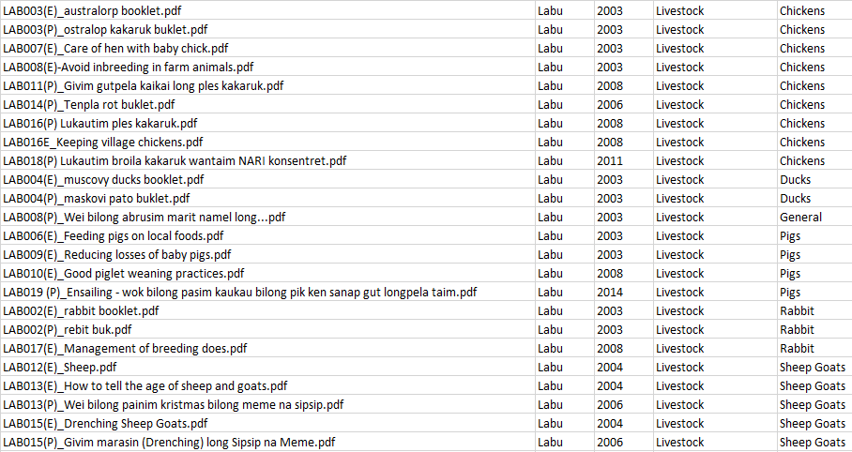
Table 9 Toktoks produced in Bubia, by the Grain program 2002-2017

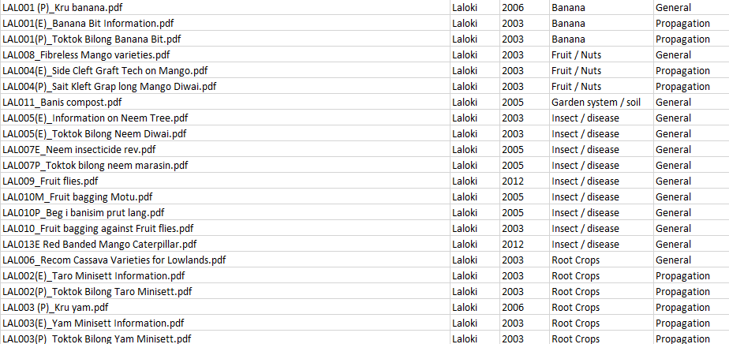
Table 10 Toktoks produced in Bubia, by the Grain program 2002-2017

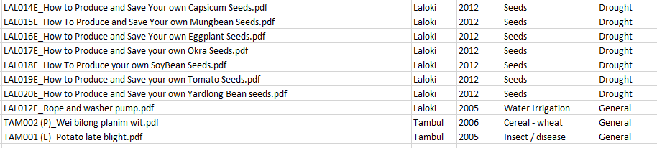
Table 11 Toktoks produced in Laloki, Central Province and in Tambul, Enga Province 2002-2017.

Taking photos for farmer extension programs
Dave Askin and David Hollander- Lincoln University

Introduction
When it comes to helping farmers understand research- the real thing is always best. The results happening in front of them, with them involved. However sometimes this isn’t possible. In that instance, a picture tells a great story. Farmers really like to see pictures- it helps them to understand what is being presented. Taking good photographs requires more preparation and care than normal photography. Plan your photography in advance. Make sure you have enough film (adequate memory if using a digital camera), spare batteries and plenty of time. If you are new to this type of photography, work slowly and methodically making notes as you go. When you view your pictures you can use the notes to recognise which techniques work and which don’t (and hopefully understand why!).

What are the key steps to great pictures for extension purposes- communicating clear messages to farming families?
Plate 1 Two photos, but each tells a different story. Use close-up facilities wisely.

Decide what information is required in the picture
Get close enough to show important information.
Know your camera- how close can you go?
This is the most important step. If you are photographing a plant, or animal for example, include just the one specimen in your picture and make sure the subject fills the picture area.

It is possible to get very close with some digital cameras. These beetles were taken with a low resolution, Sony camera, set to wide angle and then focused in very close. The matchstick gives a very reasonable indication of size. Always seek to show size- pens, Kina coins, a hand are good. For scientific reports, you will need a cm rule.

Arrange the subject and/or the camera to present the essential information as clearly as possible.
Where you take the picture from (i.e. the position of the camera relative to the subject) is one of the most powerful photographic controls.
Spend some time placing the camera (and the subject if it is movable) so the picture shows the features you wish to describe.
With some subjects (e.g. animals) you may need to take several pictures to be sure of getting a good one.

Avoid cluttered pictures / Look at the background
Make sure you cut out of the picture all the bits and pieces that detract from what the picture is saying. (This doesn’t mean telling lies with carefully chosen photos that only tell half of the story…).
Look carefully through the viewfinder to see exactly what is included in your picture.
We tend to concentrate on just the parts of the picture we think are important, but the camera will record everything equally. If there are any unnecessary features in your picture, remove them. It may be possible simply to move the offending items, or you may have to move your location.
Before taking the picture, look carefully at the edges of the viewfinder frame. Are there any distractions at the very edges of your picture? If so, get rid of them. (If you can’t get rid of them remember that you can edit photos/crop photos later once they are in a digital format on your computer.

Cameras need to be held firmly
Put the camera on a tripod! If you don’t have a tripod, consider what other firm objects can be used to help you hold the camera steady.
If necessary check focus.
When the time comes squeeze the shutter- don’t jab it.

Move in close – fill the frame with the subject.
Having checked your picture, check it again. Probably the easiest way to improve many photos is to get closer. (Don’t just use the zoom feature on a digital camera as you may lose picture quality. Move closer before using the zoom facility).
Some digital cameras have an option called close-up- use the image of a tulip flower to allow you to get close to the item.
Be careful with some simple cameras that you don’t move too close. If you can focus the lens you will be able to check focus, but with many simple non-focus cameras anything closer than a metre will be out-of-focus.
Check this by taking some photos and measuring and recording distance from lens to subject. See how they turn out.

Look carefully at the background – will it interfere with the subject?
Depending on the subject matter, there may be little you can do about the background.
However in many cases (e.g. photos of small specimens, particularly where these are moveable) you can improve the picture by having a simple, plain background that contrasts with your subject.
You may be able to use the wall of a building or introduce an artificial background (e.g. a piece of clean card) to separate your subject from its surroundings. (The close-up photos of insects in this section were taken on a canvas hat- you didn’t notice that- and that was the way it was designed!).

If a horizon is included in the picture, make sure it is horizontal!
If this seems obvious, think again! It’s amazing how many photos have sloping horizons. This is easily corrected, but you have to think of it first!

Examine the lighting carefully before taking pictures
If there is a bright background your photo is likely to look very dark and will be poor quality. Taking photos inside of a person standing near a window will ensure the person will just be a silhouette.
Is part of the subject in shade and part in sunlight? If so, the two parts will not record well in your picture. Ensure lighting is even over the whole of your subject.
The best lighting to use is bright overcast (no strong shadows). If you can wait for a bright cloudy day, do so. If not, you may be able to photograph small moveable subjects in an area of open shade (e.g. the shadow side of a building). Or you may be able to use a well-lit area indoors, but be careful to turn off any artificial lighting! Working indoors may require long exposure times (anything longer than 1/60 sec can cause blurred photos), so be sure to use your tripod.
You can take good photos on a sunny day but the lighting is more difficult to control. If you are working with small subjects in a sunny situation, you can improve your pictures by using a reflector board (any large white surface) near the subject (but out of the picture) on the opposite side to the sun. This will lighten the shadows, making it easier to see detail in both highlight and shadow areas.
If working in a large-scale situation, work with the sun coming over one shoulder (i.e. not directly behind you and not too much to one side). Avoid shooting into the sun (i.e. with the sun in front of the camera)—this can produce effective lighting for some situations but is difficult to control.

Include labels and/or scale as appropriate
Plate 2 Background is good- but labels and scale need improving. If leaves are important, then take some close-up photos of the leaves separately.
Plan ahead.
Include a label in each photo – prepare this before you go outside to take photographs.
If you are photographing a series of subjects, it is vital to know what treatment is being recorded in each picture so that you can correctly identify your pictures in the future..
Labels must be legible and neat and the right size- normally plain fonts set at 36 points will work well.
Hand written labels can look scruffy and give your work a slapdash appearance.
Prepare your labels on a computer…keep the amount of text to a minimum.
You will need to prepare some system of supporting the labels in your pictures.
Make sure the correct label is used in each picture!
When you have finished, get your film processed promptly.

.
Remember to make backups and store these away from your computer.
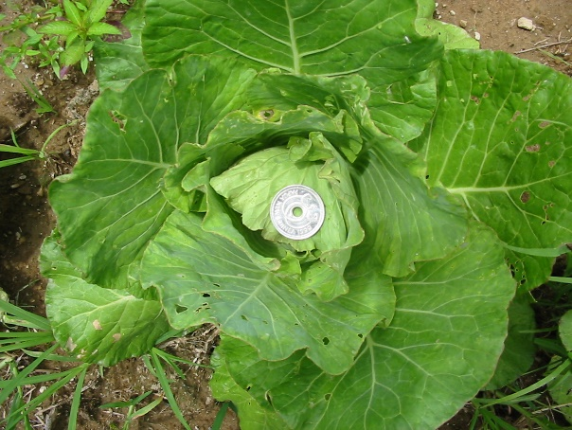 |  | 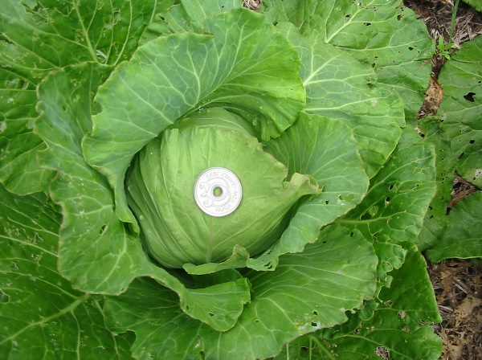
Vudal University farm-  With and without mulch- which is which?  Closeup images need more than arrows – they need words to add clarity…even though the mulch on the right is visible. | 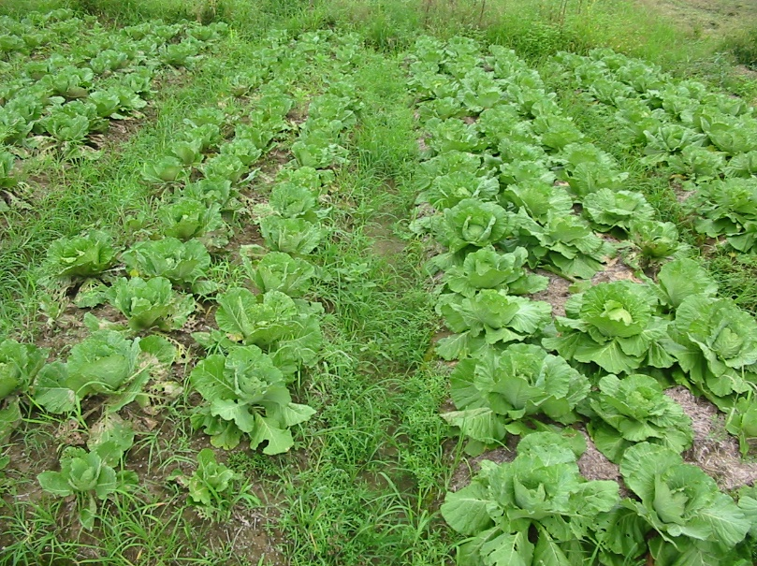

Imagine a see saw seeking balance. Chosen strategies refers to BOTH villager involvement in priority setting AND researcher / NARI officer with experience beyond that of villagers – knowing of plant material and processes outside the knowledge of the village community.
This document assumes that change is not only needed, but vitally important. That isn’t argued here. Our mutual experiences of the 1997 and 2015 El Nino droughts (with destructive fires, insects and frosts) mean that the efforts to allow villagers new opportunities through plant material and new ways of working – are crucially important.
Written extension brochures – Normally 4-8 A5 pages.
http://gutpela-png-gaden.net/library/record/view/id/43
Please disregard for the moment the technical challenge of providing tablets to show videos, along with associated solar charging / batteries / controllers and multimedia projectors. That is dealt with on page 16.
Understand that NARI has specific ways of referring to programs – I am sure the reader understand the intent of these categories.
These notes were written a long time ago! They are still relevant! NB Now we need a whole new set of notes, encouraging excellence in videos that are played on mobile phones and shared phone to phone, without costing data.

